Hexagonal Rotunda
# Source: AI Source: Provided by: [Data Path: Persons Table -> ID Column: 1, Name_En Column: Motasem Essam] -> From: [ChatGPT] on [7/25/2026]
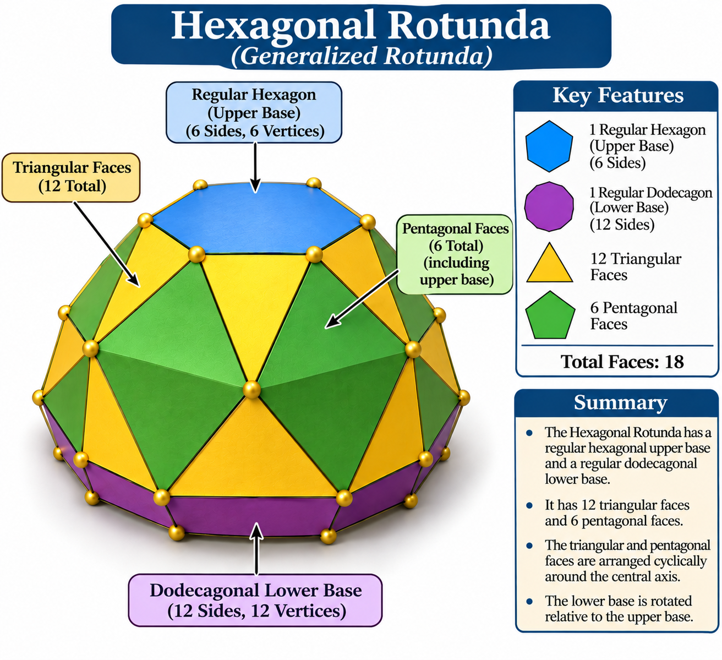

Definition
# Source: AI Source: Provided by: [Data Path: Persons Table -> ID Column: 1, Name_En Column: Motasem Essam] -> From: [ChatGPT] on [7/25/2026]
A Hexagonal Rotunda is a generalized member of the Rotunda family, characterized by a hexagonal upper base, a dodecagonal lower base, and a cyclic arrangement of triangular and pentagonal lateral faces.
It follows the general rotunda construction, in which an $n$-sided polygon is connected to a parallel $2n$-sided polygon through a band of triangular and pentagonal faces.
Important: The Pentagonal Rotunda is the only classical rotunda that forms a convex polyhedron with all regular polygonal faces and equal edge lengths. The Hexagonal Rotunda is a generalized rotunda and is not a Johnson solid. <Cite refs={["turn861858search0","turn861858search12","turn861858search14"]}/>

Geometric Structure
# Source: AI Source: Provided by: [Data Path: Persons Table -> ID Column: 1, Name_En Column: Motasem Essam] -> From: [ChatGPT] on [7/25/2026]
The Hexagonal Rotunda consists of:
- Upper Base: A hexagonal polygon with six sides and six vertices.
- Lower Base: A dodecagonal polygon with twelve sides and twelve vertices.
- Triangular Faces: Twelve triangular lateral faces.
- Pentagonal Faces: Six pentagonal lateral faces.
- Alternating Arrangement: Triangular and pentagonal faces are arranged cyclically around the central axis.
The lower base is rotated relative to the upper base as part of the rotunda construction. <Cite refs={["turn861858search0","turn861858search12"]}/>

Face Composition
# Source: AI Source: Provided by: [Data Path: Persons Table -> ID Column: 1, Name_En Column: Motasem Essam] -> From: [ChatGPT] on [7/25/2026]
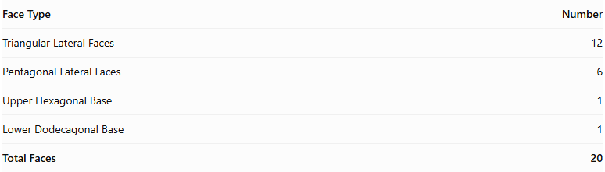
Face Type | Number
Triangular Lateral Faces | 12
Pentagonal Lateral Faces | 6
Upper Hexagonal Base | 1
Lower Dodecagonal Base | 1
Total Faces | 20
The twelve triangular faces and six pentagonal faces form the lateral structure connecting the two polygonal bases.

Mathematical Properties
# Source: AI Source: Provided by: [Data Path: Persons Table -> ID Column: 1, Name_En Column: Motasem Essam] -> From: [ChatGPT] on [7/25/2026]
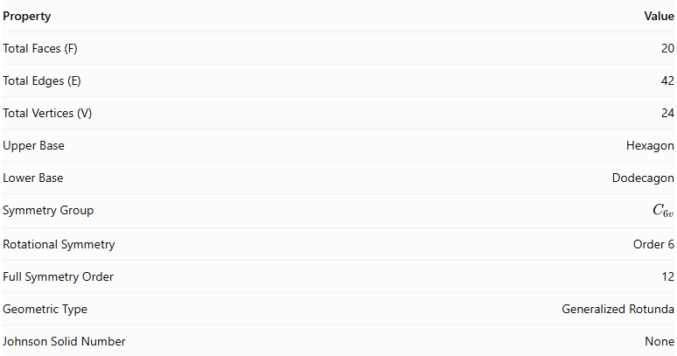
Property | Value
Total Faces (F) | 20
Total Edges (E) | 42
Total Vertices (V) | 24
Upper Base | Hexagon
Lower Base | Dodecagon
Symmetry Group | $$C_{6v}$$
Rotational Symmetry | Order 6
Full Symmetry Order | 12
Geometric Type | Generalized Rotunda
Johnson Solid Number | None
<Cite refs={["turn861858search12","turn861858search0"]}/>
General Rotunda Formulas:
For an $n$-gonal Rotunda:
$$F=3n+2, E=7n, V=4n$$
For the Hexagonal Rotunda, $n=6$:
$$F=20, E=42, V=24$$
Euler's Polyhedron Formula:
$$V-E+F=2$$
$$24-42+20=2$$

Geometric Characteristics
# Source: AI Source: Provided by: [Data Path: Persons Table -> ID Column: 1, Name_En Column: Motasem Essam] -> From: [ChatGPT] on [7/25/2026]
- Hexagonal Upper Base: Its upper base consists of six sides and six vertices.
- Dodecagonal Lower Base: Its lower base consists of twelve sides and twelve vertices.
- Triangular Lateral Faces: Twelve triangular faces form part of the lateral surface.
- Pentagonal Lateral Faces: Six pentagonal faces connect the upper and lower portions.
- Sixfold Rotational Symmetry: Its arrangement repeats after a rotation of ${60}^{∘}$.
- Cyclic Arrangement: Its lateral faces are arranged around a central axis.
- Rotunda Construction: It follows the general rotunda arrangement of triangular and pentagonal lateral faces.
- Johnson Solid Relationship: Unlike the Pentagonal Rotunda (J6), the Hexagonal Rotunda is not a Johnson solid because it does not have the required regular-faced, equal-edge construction.

Construction of Hexagonal Rotunda

Geometric Instruments Used
# Source: AI Source: Provided by: [Data Path: Persons Table -> ID Column: 1, Name_En Column: Motasem Essam] -> From: [ChatGPT] on [7/25/2026]
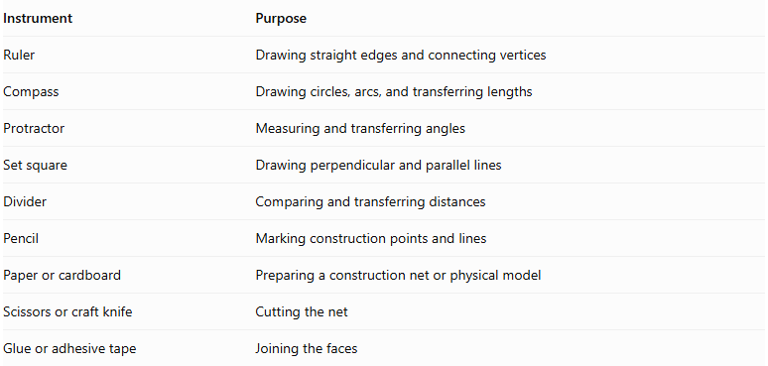
Instrument | Purpose
Ruler | Drawing straight edges and connecting vertices
Compass | Drawing circles, arcs, and transferring lengths
Protractor | Measuring and transferring angles
Set square | Drawing perpendicular and parallel lines
Divider | Comparing and transferring distances
Pencil | Marking construction points and lines
Paper or cardboard | Preparing a construction net or physical model
Scissors or craft knife | Cutting the net
Glue or adhesive tape | Joining the faces

Instrument-Based Construction Procedures
# Source: AI Source: Provided by: [Data Path: Persons Table -> ID Column: 1, Name_En Column: Motasem Essam] -> From: [ChatGPT] on [7/25/2026]
No coordinate-based construction
The construction uses geometric instruments, polygon geometry, measured lengths, angles, and face-to-face edge matching. It does not use coordinate axes, coordinate points, or coordinate equations.

Construct the Upper Regular Hexagonal Base
# Source: AI Source: Provided by: [Data Path: Persons Table -> ID Column: 1, Name_En Column: Motasem Essam] -> From: [ChatGPT] on [7/25/2026]
- Draw a circle using a compass.
- Mark a point on the circumference.
- Set the compass to the circle's radius.
- Step this radius around the circumference to mark six equally spaced points.
- Join consecutive points using a ruler.
- Verify that the six sides are equal.
- Label the vertices $A,B,C,D,E,F$.

Construct the Lower Regular Dodecagonal Base
# Source: AI Source: Provided by: [Data Path: Persons Table -> ID Column: 1, Name_En Column: Motasem Essam] -> From: [ChatGPT] on [7/25/2026]
- Draw a second circle using a compass.
- Construct six equally spaced points on its circumference to form a regular hexagon.
- Bisect each central angle between consecutive hexagon vertices.
- Mark the six additional points on the circumference.
- Join all twelve consecutive points using a ruler.
- Verify that the resulting regular dodecagon has twelve equal sides.
- Label the vertices $P_{1},P_{2},…,P_{12}$.
A regular dodecagon can be constructed exactly using a compass and straightedge.

Construct the Twelve Triangular Lateral Faces
# Source: AI Source: Provided by: [Data Path: Persons Table -> ID Column: 1, Name_En Column: Motasem Essam] -> From: [ChatGPT] on [7/25/2026]
- Prepare twelve triangular faces using a ruler, compass, and protractor.
- Determine their side lengths and angles from the selected Hexagonal Rotunda model.
- Arrange the triangles in the required lateral pattern.
- Match their edges to the corresponding edges of the pentagonal faces and the two bases.
- Verify that each triangle fits its neighboring faces correctly.

Construct the Six Pentagonal Lateral Faces
# Source: AI Source: Provided by: [Data Path: Persons Table -> ID Column: 1, Name_En Column: Motasem Essam] -> From: [ChatGPT] on [7/25/2026]
- Prepare six pentagonal faces.
- Determine their side lengths and interior angles from the selected model.
- Arrange the pentagons alternately within the lateral face arrangement.
- Match their edges with the appropriate neighboring triangular faces.
- Verify that the six pentagons complete the lateral structure without gaps or unintended overlaps.

Arrange the Faces
# Source: AI Source: Provided by: [Data Path: Persons Table -> ID Column: 1, Name_En Column: Motasem Essam] -> From: [ChatGPT] on [7/25/2026]
- Position the regular hexagonal upper base and regular dodecagonal lower base parallel to each other.
- Arrange the twelve triangles and six pentagons between the two bases.
- Check the lengths of all shared edges.
- Verify the intended sixfold rotational symmetry.
- Confirm that every edge belongs to exactly two faces and that the surface closes correctly.

Assemble the Solid
# Source: AI Source: Provided by: [Data Path: Persons Table -> ID Column: 1, Name_En Column: Motasem Essam] -> From: [ChatGPT] on [7/25/2026]
- Prepare a verified construction net or separate face pieces with the correct adjacency arrangement.
- Add joining tabs if using paper or cardboard.
- Cut out the faces.
- Fold the required edges if using a net.
- Join the matching lateral faces.
- Attach the upper hexagonal base and lower dodecagonal base.
- Inspect the completed model from several directions.
Construction accuracy: The six pentagons and twelve triangles must have dimensions and angles compatible with the chosen generalized model. Simply using six regular pentagons, twelve equilateral triangles, a regular hexagon, and a regular dodecagon with one common edge length does not guarantee a valid closed Hexagonal Rotunda. The face geometry and adjacency must be verified before assembly.

Key Points
# Source: AI Source: Provided by: [Data Path: Persons Table -> ID Column: 1, Name_En Column: Motasem Essam] -> From: [ChatGPT] on [7/25/2026]
- Upper Base: Hexagon.
- Lower Base: Dodecagon.
- Triangular Lateral Faces: 12.
- Pentagonal Lateral Faces: 6.
- Total Faces: 20.
- Total Edges: 42.
- Total Vertices: 24.
- Rotational Symmetry: Order 6.
- Classification: Generalized Rotunda.
- Johnson Solid: Not a Johnson solid.

Main Classification
# Source: AI Source: Provided by: [Data Path: Persons Table -> ID Column: 1, Name_En Column: Motasem Essam] -> From: [ChatGPT] on [7/25/2026]
Solid Geometry
└── Types of Solids
└── Rotunda
└── Types of Rotundas
└── Hexagonal Rotunda

Conclusion
# Source: AI Source: Provided by: [Data Path: Persons Table -> ID Column: 1, Name_En Column: Motasem Essam] -> From: [ChatGPT] on [7/25/2026]
The Hexagonal Rotunda is a generalized rotunda characterized by its hexagonal upper base, dodecagonal lower base, and cyclic arrangement of twelve triangular and six pentagonal lateral faces. Its combinatorial structure has 20 faces, 42 edges, and 24 vertices, with sixfold rotational symmetry.
Important distinction: The Hexagonal Rotunda is different from the Hexagonal Cupola. The Hexagonal Cupola has triangular and square lateral faces, whereas the Hexagonal Rotunda has triangular and pentagonal lateral faces. <Cite refs={["turn861858search0","turn861858search12"]}/>

